CCDM governance is about…
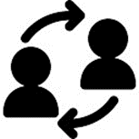

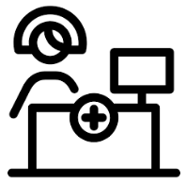

… planning, coordinating and monitoring
CCDM governance is a permanent structure that plans and coordinates care capacity demand management for staff and patients. To be successful CCDM governance needs an active partnership between the DHB and health unions.

…connecting people with action
Governance is a formal structure that connects people with process. Setting the strategy, plan of work, and monitoring progress against the CCDM programme standards.

…being accountable to each other
Governance promotes joint decision making, accountability and response – ability. CCDM governance enables high performance, high engagement. The pace and scale of CCDM is determined by the success of governance.

…you and you and you and you
Staff from all levels of the hospital and health unions are involved in CCDM governance. Ward meetings, service meetings, operations meeting, quality groups and council are all groups where you can get involved.

…to start or already up and running
You can find out more from your CCDM Site Coordinator, union delegate or clinical manager.

…the timeline of events includes

<You could use this example, delete the other>

What | Who | When
Agree CCDM council participants | DHB Executive/health union | May
Arrange meetings | Administrator | May
Establish co-chairs and agree terms of reference | CCDM council | May
Education on tools and process | CCDM Site Coordinator  SSHW Unit Programme Consultant | June
Undertake partnership evaluation and agree next steps | CCDM council | June
Develop draft workplans | CCDM Site Coordinator  SSHW Unit Programme Consultant | June
Endorse workplan | CCDM council | June
Communicate to staff | CCDM council | July

<Or you could use this example, delete the other>

