Local data council is about …
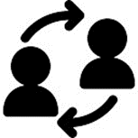

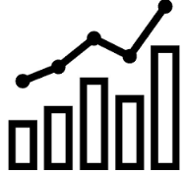

…shared decision making
The local data council is a permanent group of people that jointly identify and solve problems, and spread successful practices. The local data council is a joint governance structure for care capacity demand management.

…improving the way we work
Collaboration between frontline staff, managers and health unions is the best way to achieve quality patient care, quality work environment and best use of health resources. The people closest to the problems, involved in solving the problems.

…meeting regularly
Joint governance for care capacity demand management can occur as part of staff monthly meetings. Or separate groups can be established e.g. quality groups or local data councils. Regular meetings provide a forum to identify problems, set goals, plan change and measure results.

…the team collaborating
The team includes clinical and service managers, nursing, allied, medical, support staff, health unions and subject experts (quality, finance, Safe Staffing Healthy Workplaces Unit) as needed.

…to start on your ward soon
Ask your CCDM Site Coordinator, clinical manager or your union delegate about how you can be involved.

…the timeline of events includes

<You could use this example, delete the other>

What | Who | When
Select participants | Ward/unit staff | Week 1, May 2018
Arrange meetings | Clinical manager | Week 2, May 2018
Elect chair and agree terms of reference | Local data council | Week 3, May 2018
Education on tools and process | CCDM Coordinator  SSHW Unit Programme Consultant | Week 1 & 2, June 2018
Jointly agree issues | Local data council | Week 3, June 2018
Agree measures for monitoring | Local data council | Week 3, June 2018
Write improvement plan | Local data council | Week 4, June 2018
Communicate | Local data council | Week 1, July 2018

<Or you could use this example, delete the other>

