Care Capacity Demand Management is about…

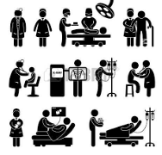

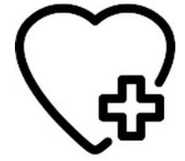

…matching your capacity to care with patient demand
CCDM is matching your staff, beds, resources, knowledge and skills to the patients coming through the doors. It is a whole of hospital approach to managing the capacity to care on a permanent basis.

…right staff, right place, right care

Safety and quality for patients and staff is a priority. The goal is to achieve better quality patient care, better work environment and best use of health resources.

…every day and every shift
Patient needs and staffing change every day, every shift. Matching our capacity to care with patient demand needs constant readjustment.

…everybody working together
Your goals can only be achieved through the combined efforts of each individual. We all have a part to play in matching the capacity to care with patient demand.

…starting now and continuing on a permanent basis
CCDM is currently being rolled out in your hospital. If you want to know more talk to your CCDM Site Coordinator, union delegate or clinical manager.

…the timeline of events includes

<You could use this example, delete the other>

What | Who | When
Select CCDM council participants | CE, DON, health unions | May
Arrange meetings | Administration | May
Agree co-chairs and agree terms of reference | CCDM council participants | May
Provide/receive CCDM education on tools and processes | CCDM Programme Consultant  CCDM Site Coordinator | June
Write draft workplan, endorse and communicate | CCDM Programme Consultant  CCDM Site Coordinator | June
Set up working groups | CCDM councils | June

<Or you could use this example, delete the other>

